NAME- Jagyanjit Rout

SIC- 22BECI74

CLASS- 8

Assignment

1. Install Docker on your local machine (if not already installed).

2. Pull an Nginx image from Docker Hub and run it as a container.

3. Create a custom Docker network and connect the Nginx container to it.

4. Verify container-to-network connection using Docker network inspect.

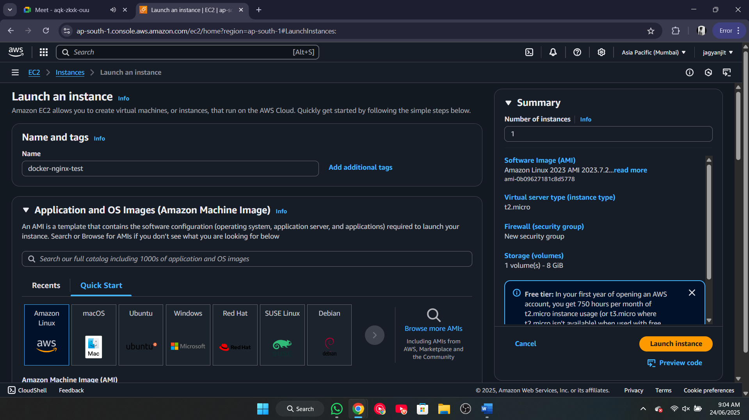

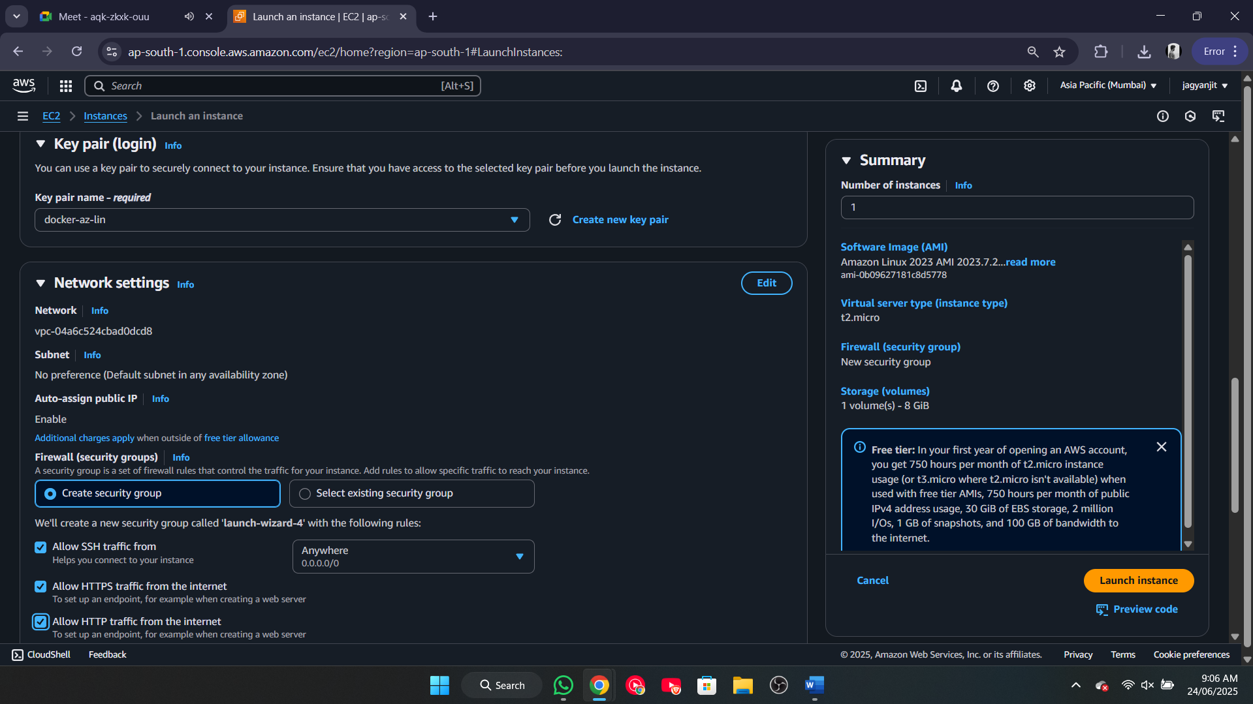

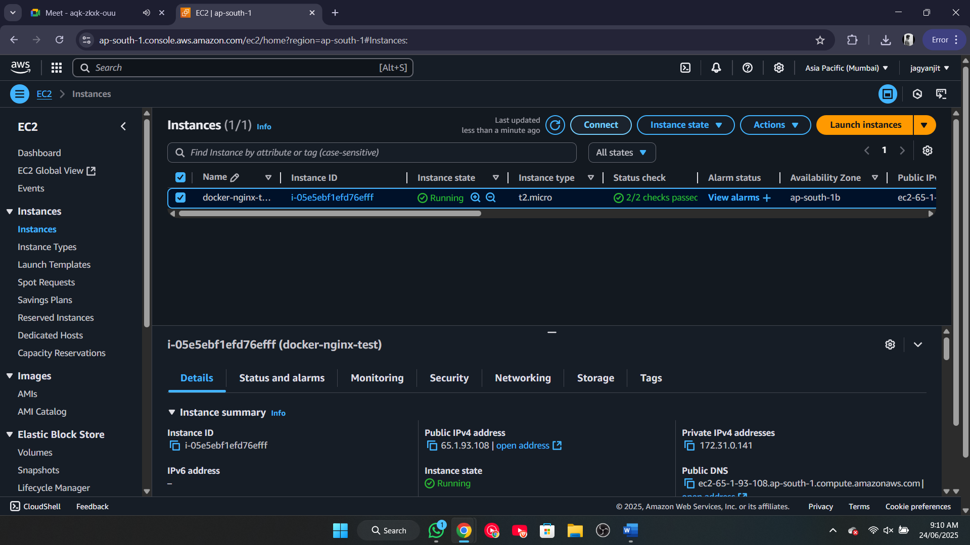

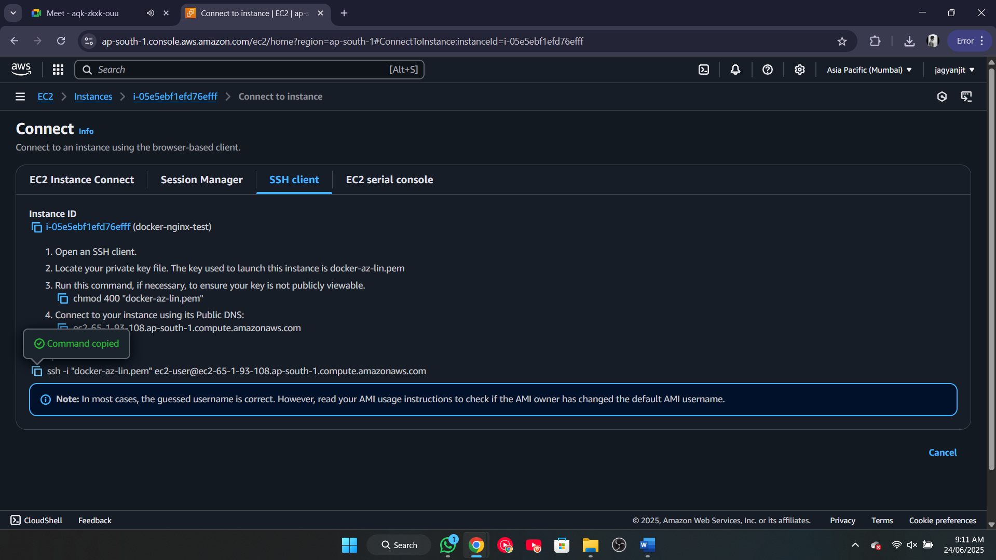

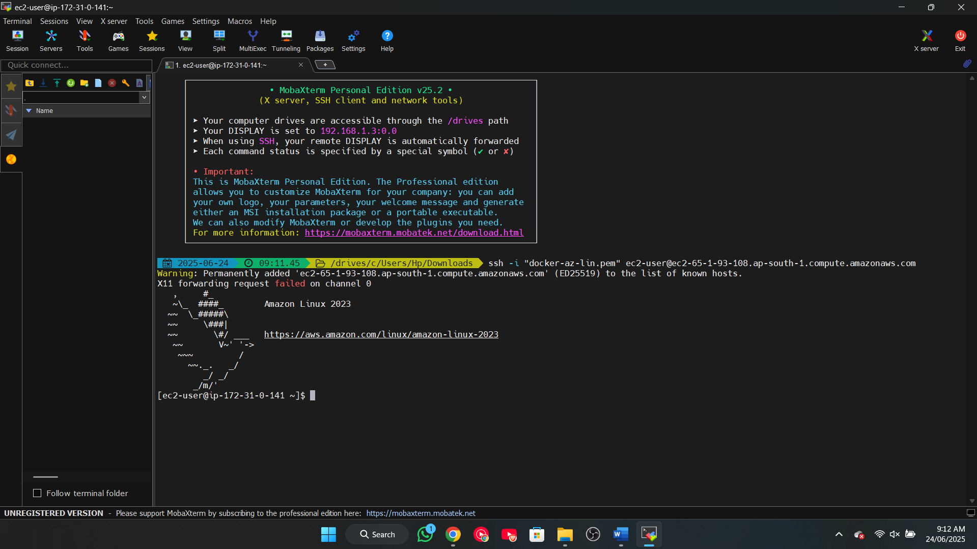

1. Install Docker on your local machine (if not already installed).

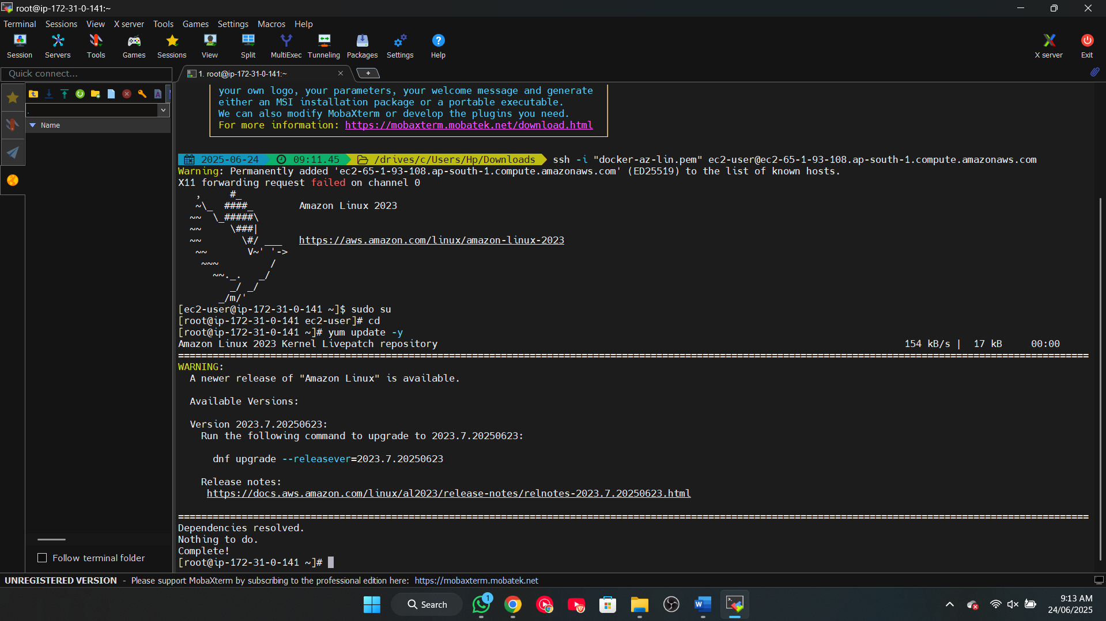

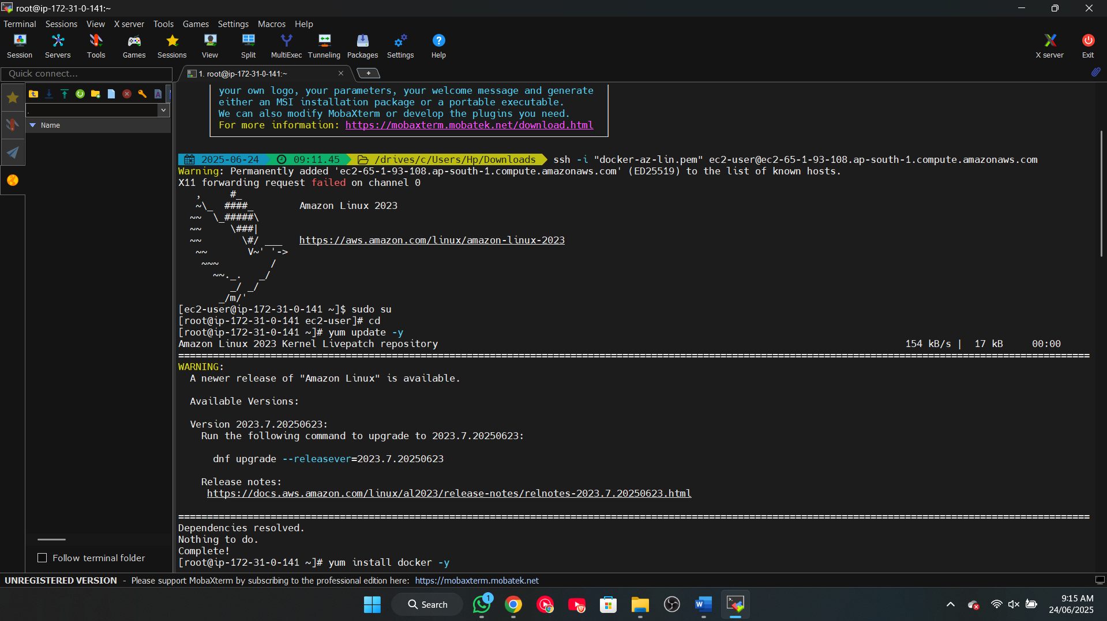

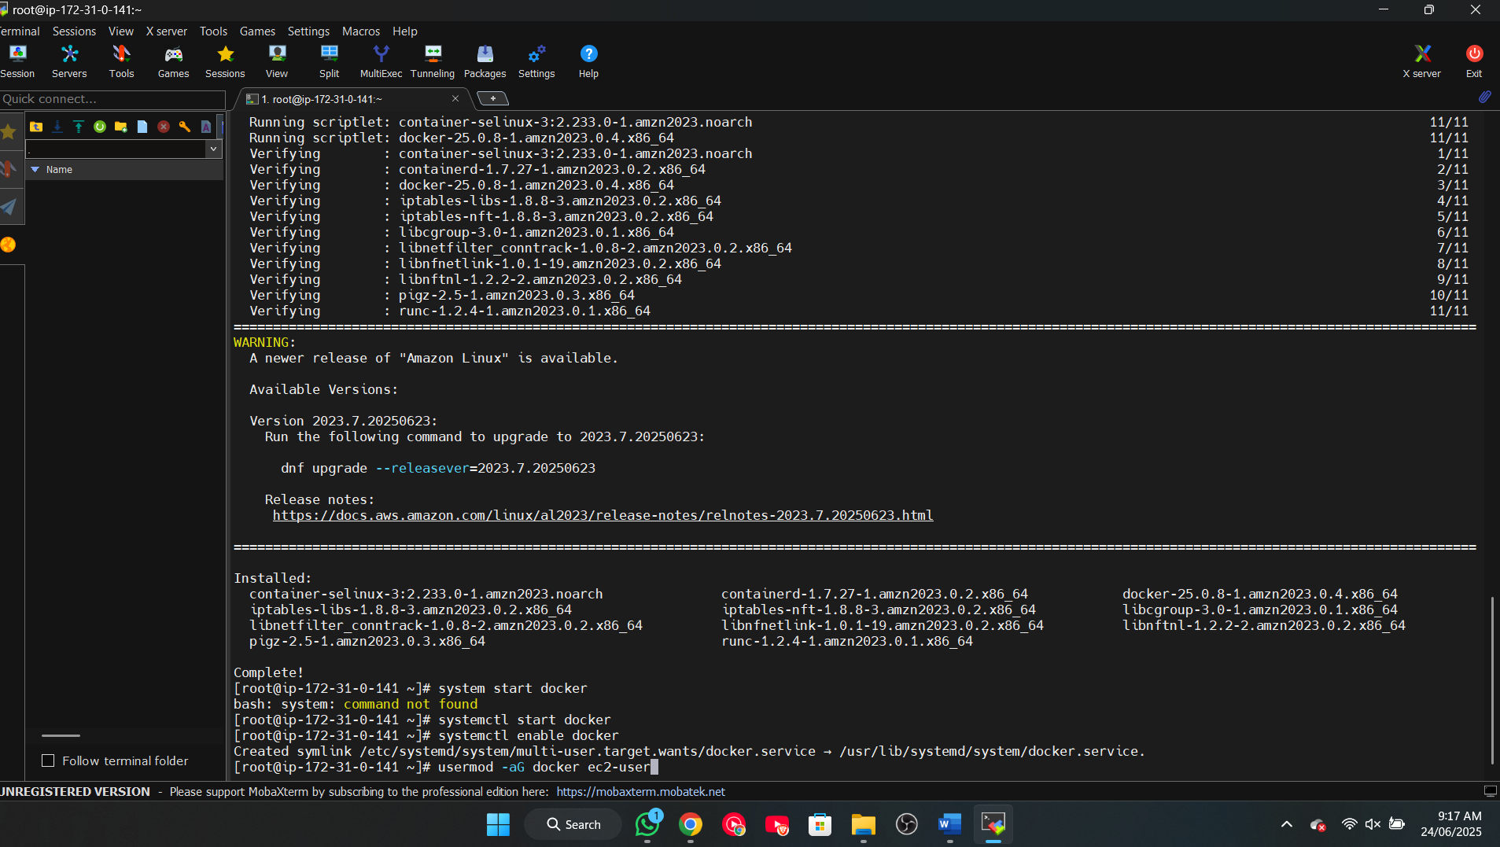

2. Pull an Nginx image from Docker Hub and run it as a container.

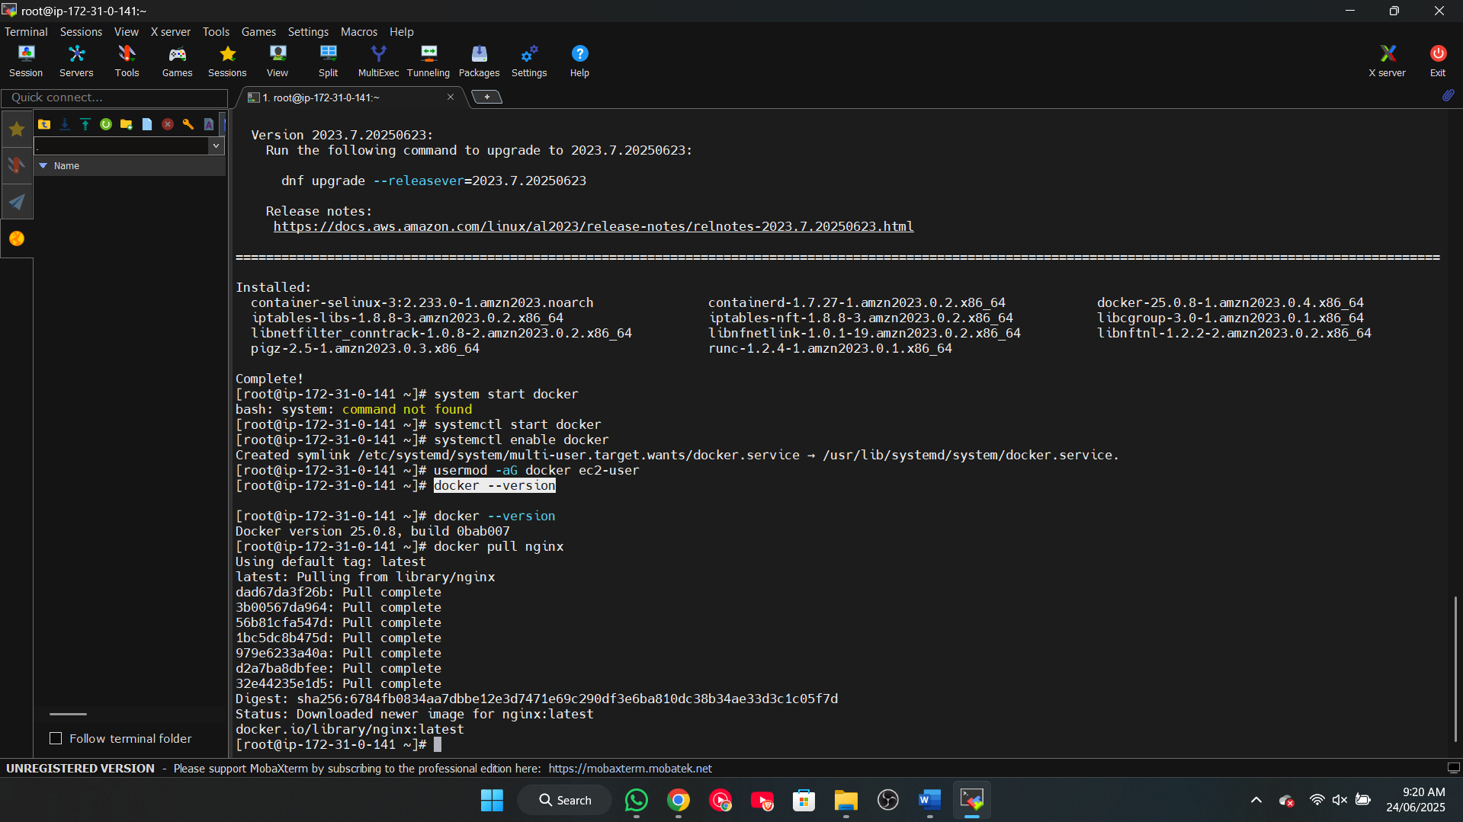

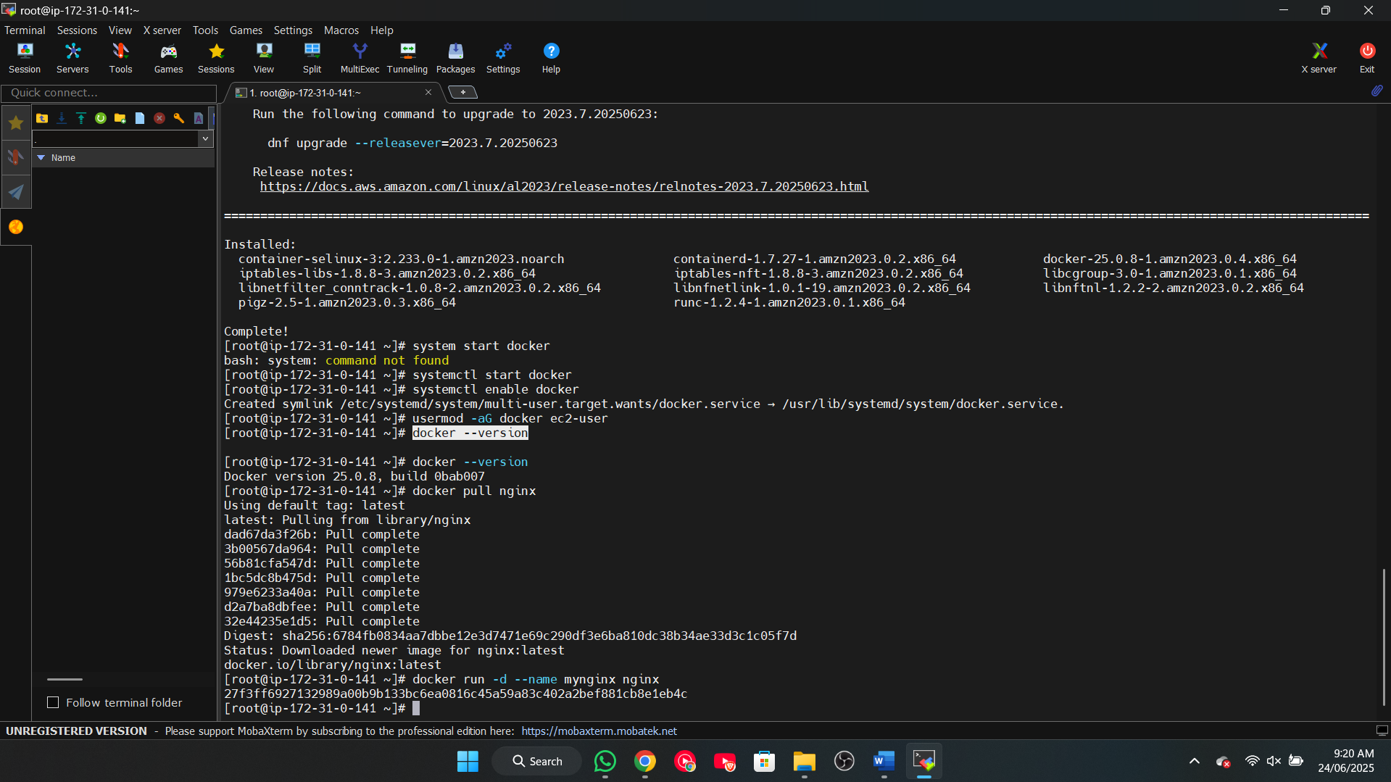

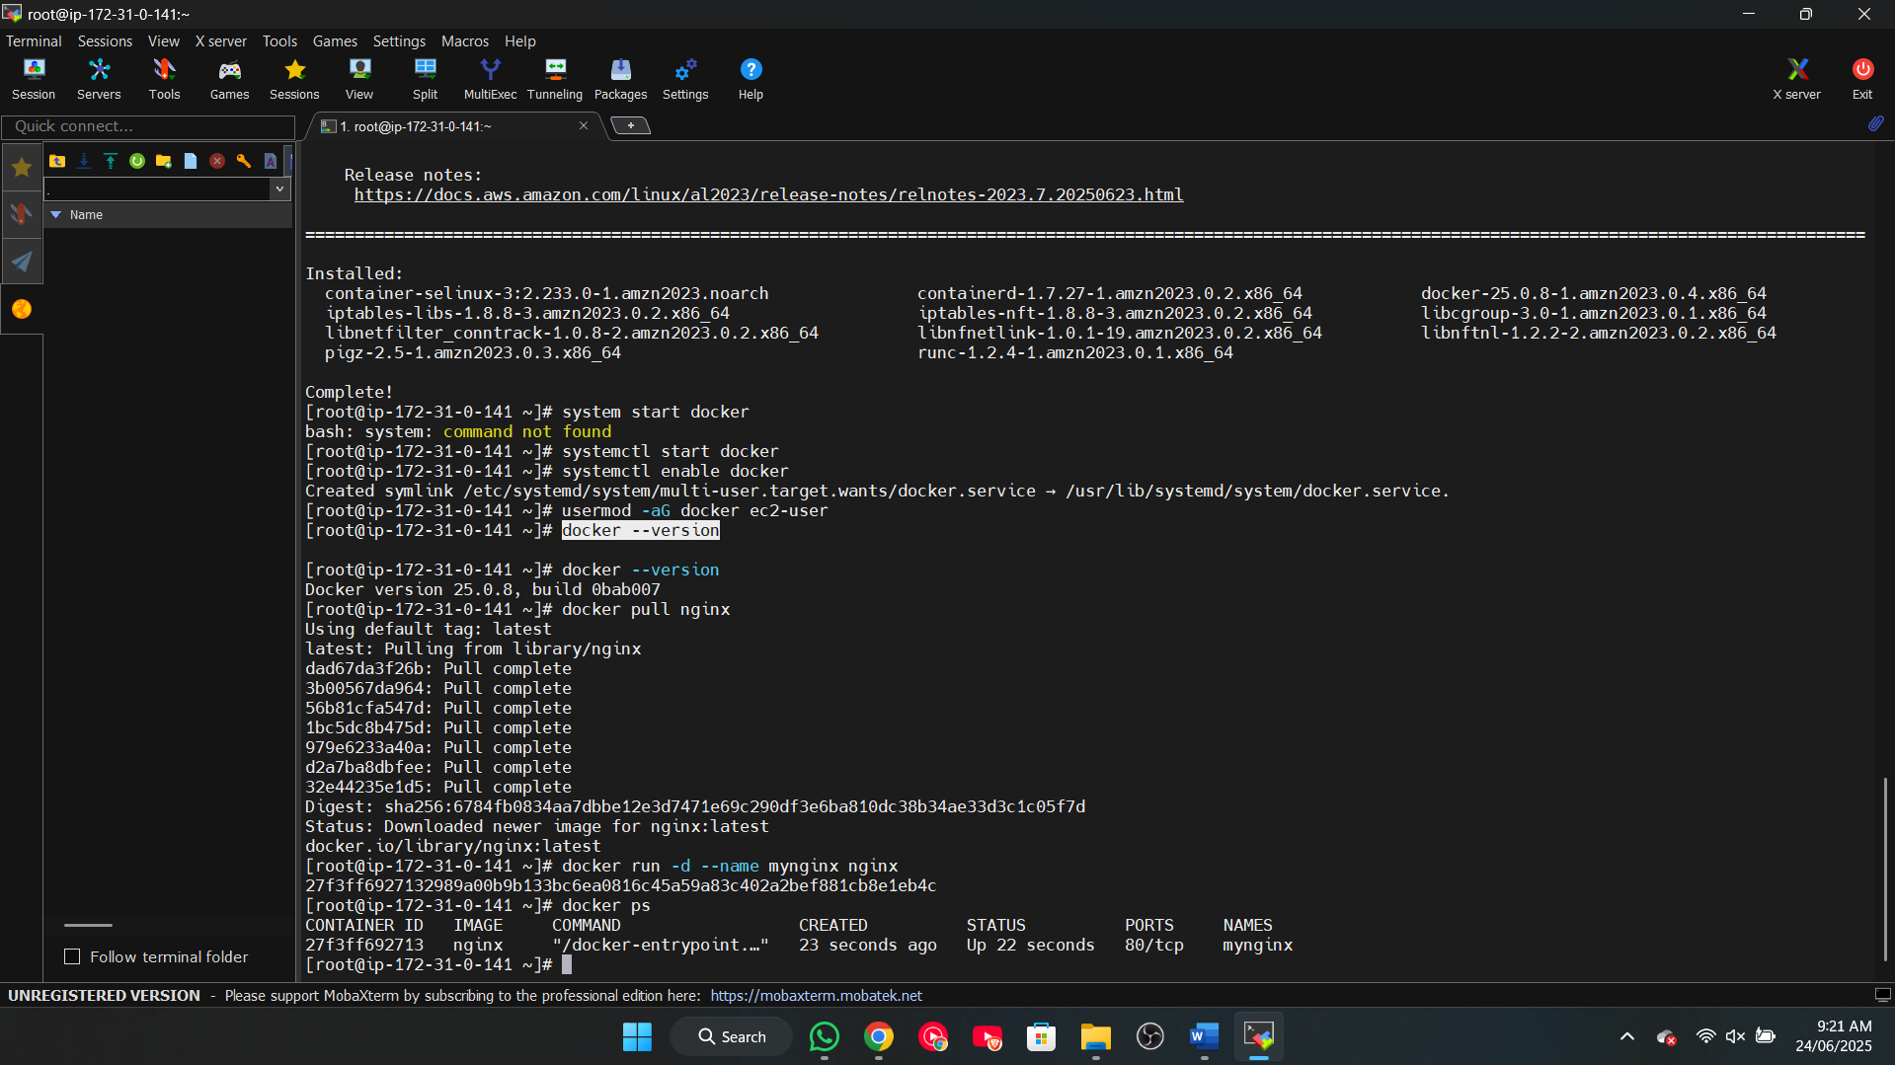

3. Create a custom Docker network and connect the Nginx container to it.

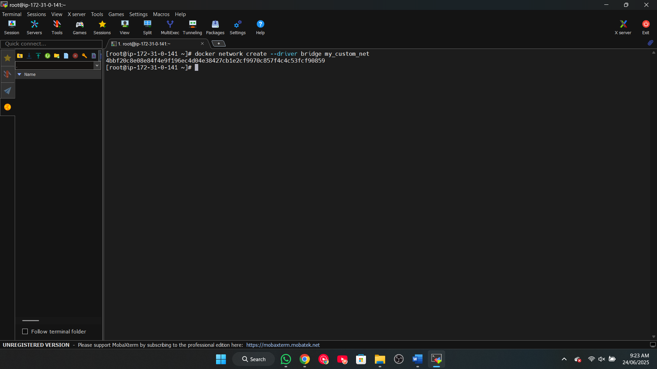

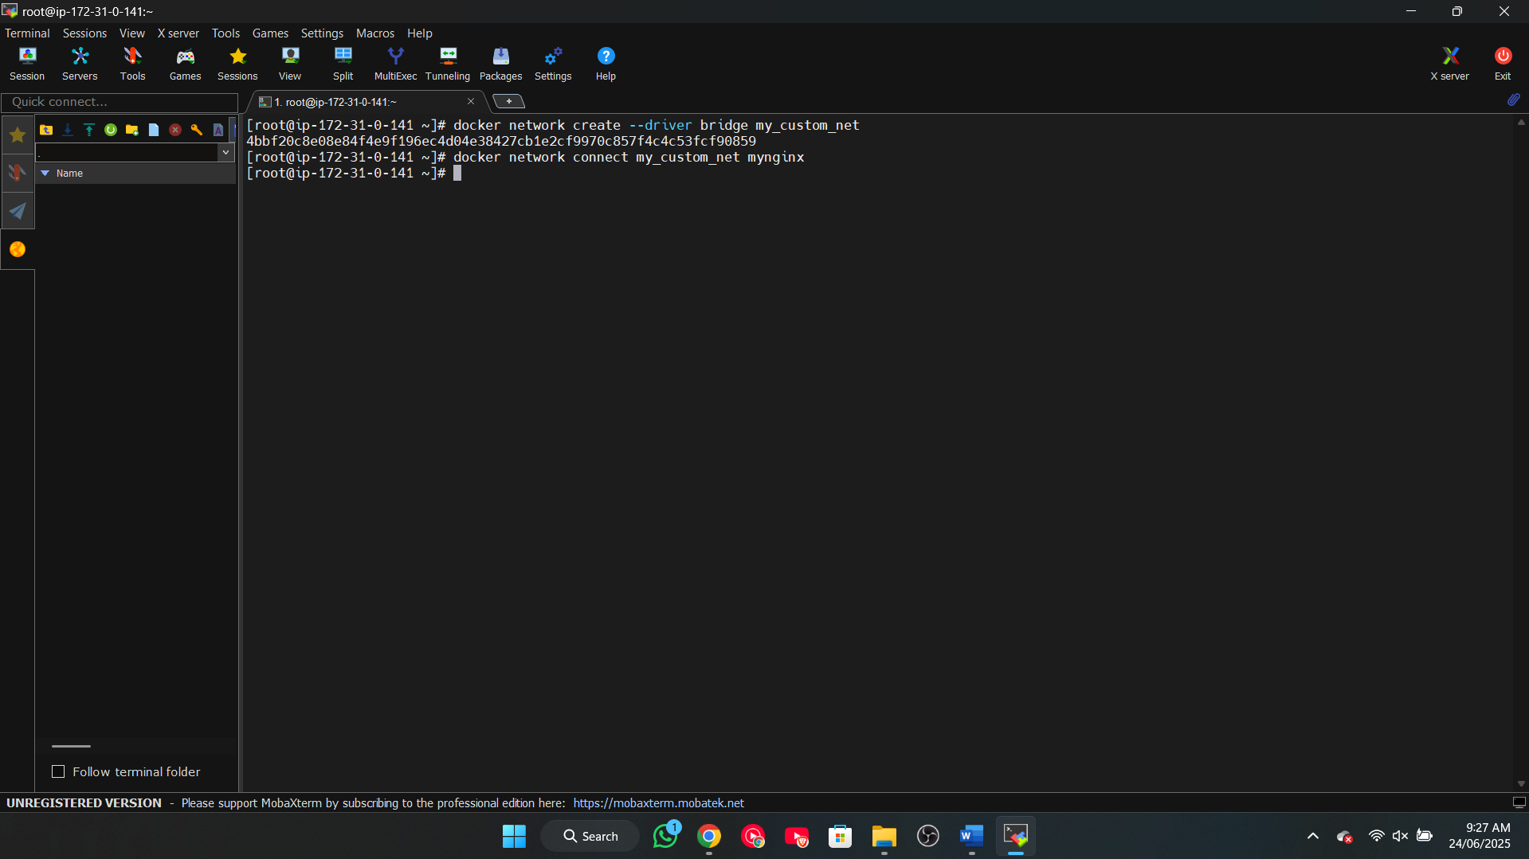

4. Verify container-to-network connection using Docker network inspect.

